

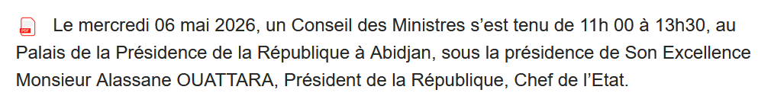
[…]
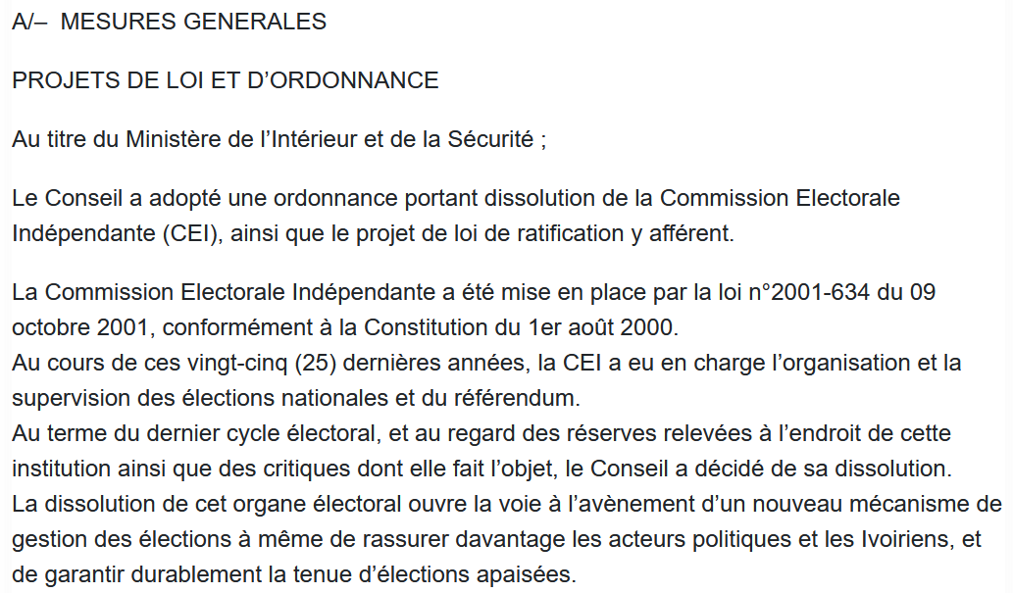

SOURCE : https://web.sgg.gouv.ci/publications/conseils-des-ministres/details/3270

